**Experiment 9: Simple application using Servlet**

**Aim:** To make a simple application using Servlet

**Tags Used:**

<form>

<table>

<tr>

<td>

**Implementation:**

**Output:**

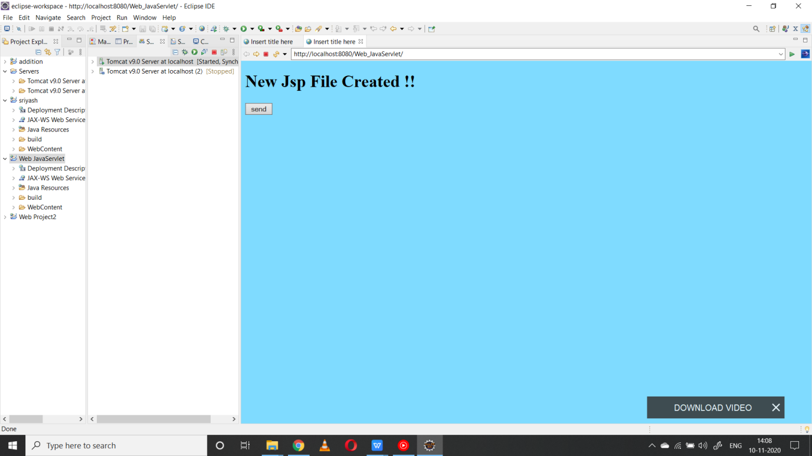

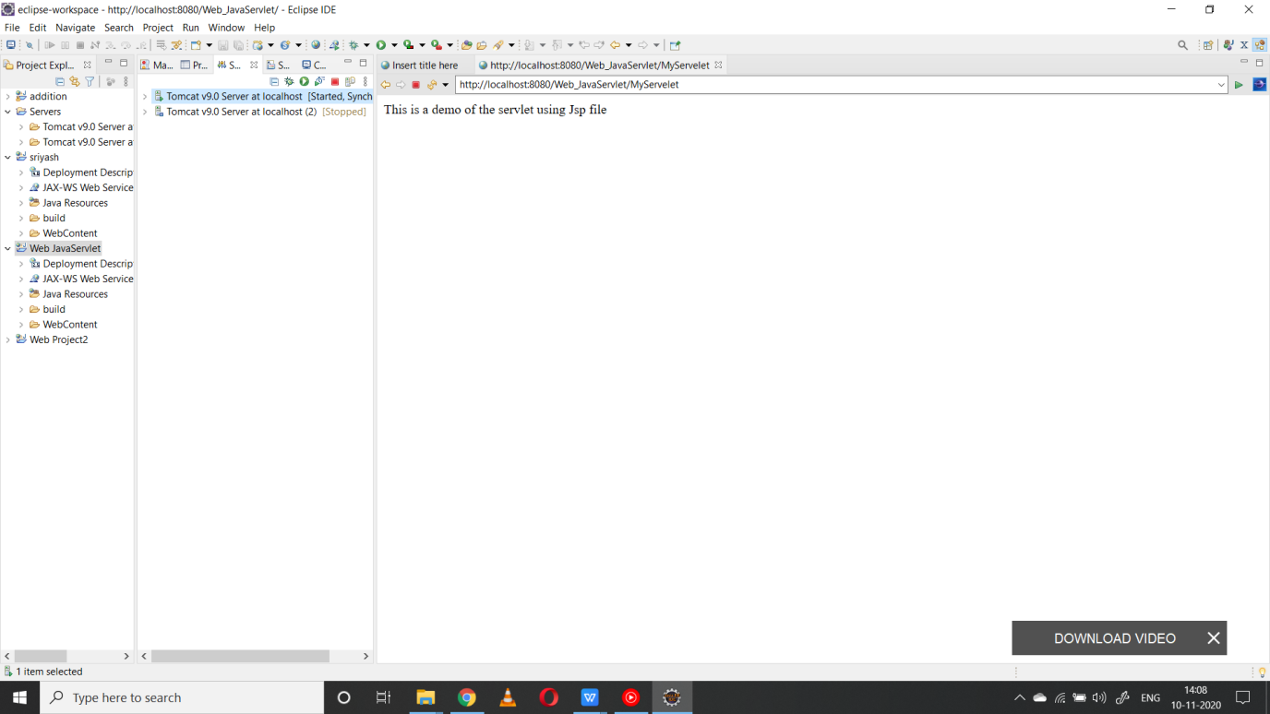

**Code:**

**Index.jsp**

<%@ page language=*"java"* contentType=*"text/html; charset=ISO-8859-1"*

pageEncoding=*"ISO-8859-1"*%>

<!DOCTYPE html PUBLIC "-//W3C//DTD HTML 4.01 Transitional//EN" "http://www.w3.org/TR/html4/loose.dtd">

<html>

<head>

<meta http-equiv=*"Content-Type"* content=*"text/html; charset=ISO-8859-1"*>

<title>Insert title here</title>

<style>

**body**

{

background-color:*#7FDBFF*;

}

</style>

</head>

<body>

<h1 style = "text-color:*white*;">New Jsp File Created !!</h1>

<form action=*"MyServelet"*>

<input type=*"submit"* value=*"send"*/></form>

</body>

</html>

**Result:**The experiment was successfully completed.